ANGULAR TUTORIAL-

How to install Angular CLI

Step 1- Visit https://nodejs.org/en/ and download nodejs and install it
Step 2- Visit https://cli.angular.io/ and refer the command written there or simply run
sudo npm install -g @angular/cli
PLz note that it may take some time

I was getting permission issue,
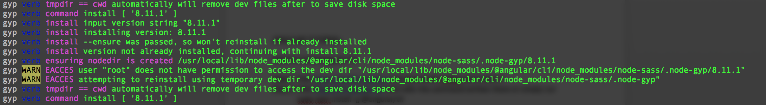
So I ran below command
sudo npm install -g --unsafe-perm --verbose @angular/cli﻿

Step 4- To create first project, locate to the folder where you want to create project and provide below command

ng new my-first-app

